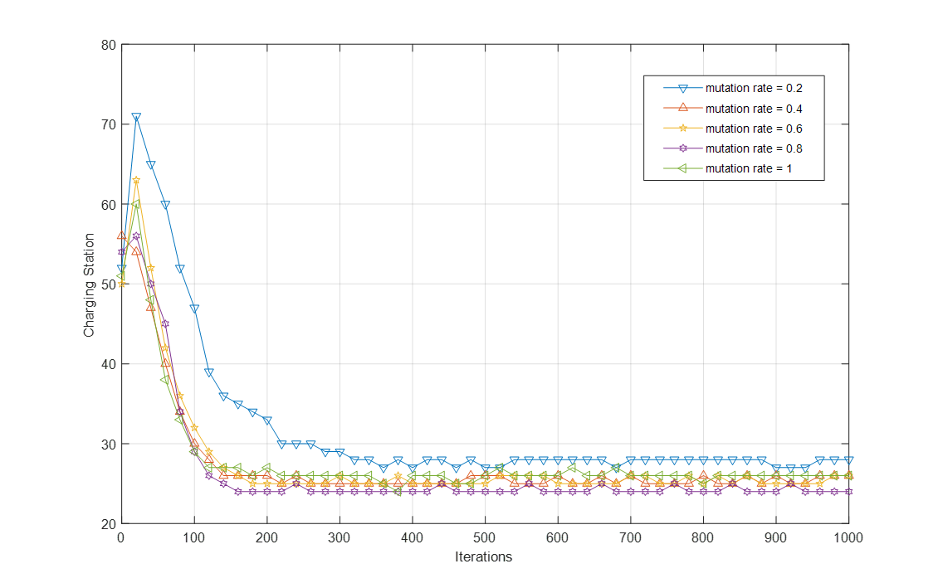

Figure 13. Effects of the mutation rate on NSGA-II convergence